**Pear and Gruyère Strata**

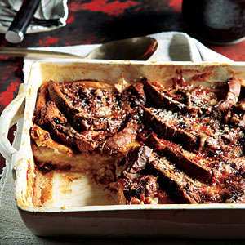

Serves 8 (serving size: 1 strata piece and 1 tablespoon syrup)

**Ingredients**

* 4 cups sliced peeled Anjou or Concorde pear
* 2 teaspoons butter, melted
* 6 tablespoons granulated sugar, divided
* 12 (1-ounce) slices cinnamon swirl bread (such as Pepperidge Farm), cut in half diagonally
* Cooking spray
* 1 cup (4 ounces) shredded Gruyère cheese
* 1 1/2 cups 1% low-fat milk
* 1 cup egg substitute
* 1/2 teaspoon ground cinnamon
* 1 tablespoon turbinado sugar
* 1/2 cup maple syrup

**Preparation**

1. Combine pear, butter, and 1 tablespoon sugar in a large bowl; toss gently.

2. Arrange half of bread in an 11 x 7-inch glass or ceramic baking dish coated with cooking spray. Spoon pear mixture evenly over bread; top evenly with cheese. Arrange remaining bread over cheese.

3. Combine the remaining 5 tablespoons granulated sugar, milk, egg substitute, and cinnamon, stirring with a whisk. Pour milk mixture over bread, pressing down to submerge. Cover and chill 8 hours or overnight.

4. Preheat oven to 350°.

5. Uncover dish. Sprinkle turbinado sugar evenly over bread. Bake at 350° for 55 minutes or until a knife inserted in center comes out clean. Let stand 10 minutes. Cut into 8 equal pieces; drizzle with syrup.